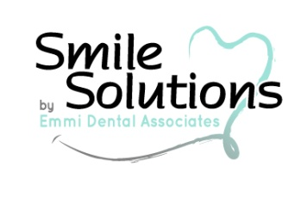
Smile Analysis (21+)

Patient Name: | Date:

What do you expect from a preventative cleaning? ________________________________________________________

__________________________________________________________________________________________________________________

- On a scale of 1-10 how would you rate your apprehension with dental visits?
(10 being very apprehensive) 1-2-3-4-5-6-7-8-9-10
- On a scale of 1-10 how important is it to keep your natural teeth?
(10 being very important) 1-2-3-4-5-6-7-8-9-10
Yes/No Are you familiar with nitrous gas?
Yes/No Do your gums bleed?
Yes/No Do you feel you have bad breath?
Yes/No Are you familiar with periodontal disease?
Yes/No Do you wish your teeth were whiter?
Yes/No Are you familiar with in-office whitening?
Yes/No Do you like the way your teeth are shaped?
Yes/No Do you use an electric toothbrush, if so what brand/model? ________________________________
Yes/No Are you interested in orthodontics?
Yes/No Are you happy with your smile?
Yes/No Do you wear dentures? What year were they made? _________________________________________
- If yes, are you happy with the feel and look of your dentures? Yes/No
Yes/No Did you know the ADA recommends getting new dentures every 5 years?

Is there anything you would like to change about your smile? ____________________________________________

__________________________________________________________________________________________________________________

Additional comments: (staff use only)

