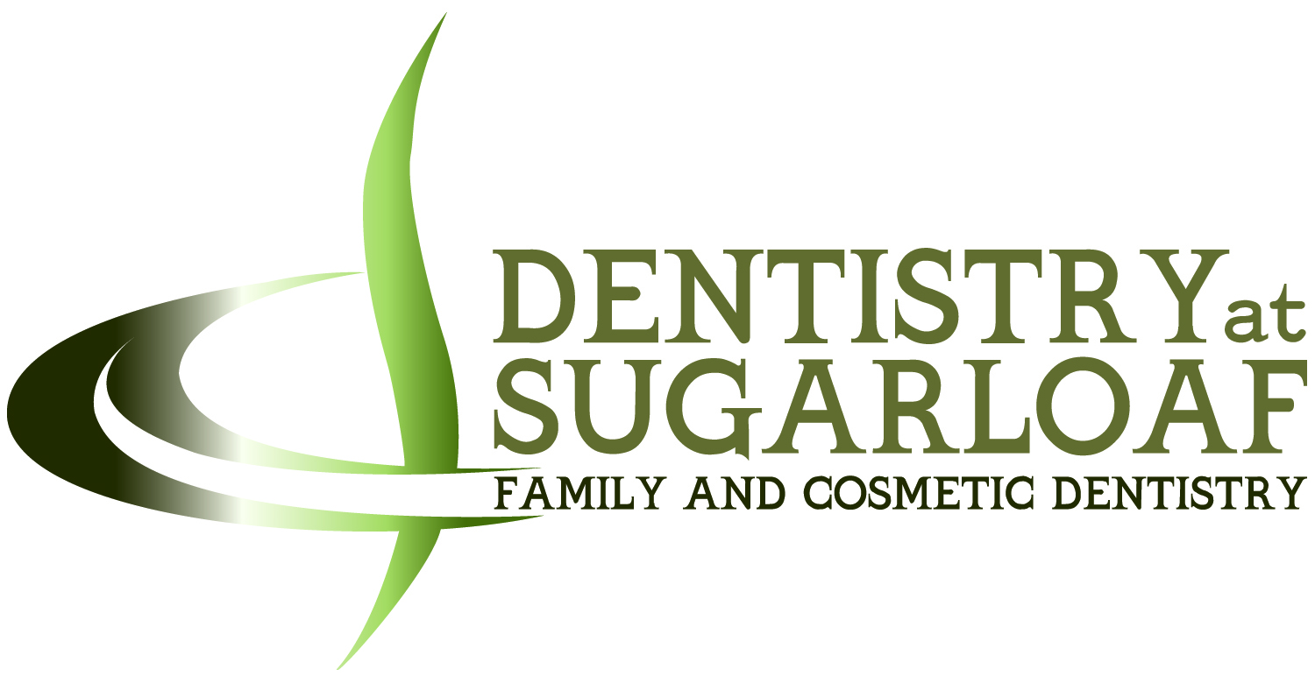

PERSONAL “SMILE” CHECKUP

Thank you for choosing Dentistry at Sugarloaf. It is our goal to exceed
your expectations for dental care and comfort—always. As you will see, we utilize
state-of-the-art technology in a spa-like setting, from laser restorative procedures to the
latest in cosmetic treatments.

The following Smile Checkup is for your convenience, should you have interest in
improving the appearance of your smile. Most people are unaware of the many
innovations available in cosmetic dentistry today . . . from professional teeth whitening to
the instant glamour of veneers. A former Clinical Instructor in Cosmetic Dentistry at the
acclaimed Nash Institute of Dental Learning, Dr. Norton is well qualified to suggest
available options, if you like.

Trouble-free and affordable cosmetic dentistry can make a difference in one’s business
and social life. More and more people are taking advantage of these amazing options.
Cosmetic dentistry used to be for celebrities only…not anymore!

PLEASE MARK AN “X” BY THE STATEMENTS WITH WHICH YOU AGREE

____ I wish the color of my teeth were whiter.

____ I think some of my teeth are too small; ____ - too large.

____ I wish my teeth were straighter.

____ I think my gums show too much when I smile.

____ I think there is too much space between some of my teeth.

____ I sometimes hesitate to smile because __________________________
________________________________________________________.

____ My concern for how the end result would appear has kept me from
having cosmetic procedures done.

____ My concern about the cost of cosmetic treatment has kept me from
having cosmetic procedures done.

____ I would like to learn more about the options available for enhancing my smile.

Patient Name___________________________________Date______________________

